Geometry CC – Mr. Valentino Name:___________________________________ Unit 7 Lesson 3: Proofs Review Date: _______________________ Period: _____
Aim: Lets Review Proofs!
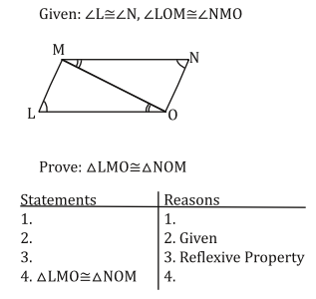
Do Now: Fill in the blanks:
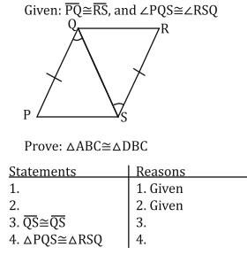

∆PQS$≅$∆RSQ

Helpful Tips: Before you begin your proof…
- Mark your diagram with all the given information
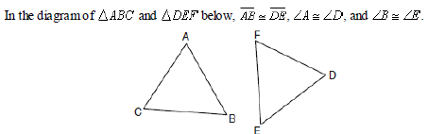
- Look for any hidden facts
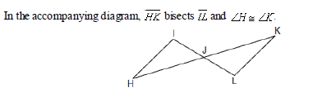
- Identify the method you will use to prove the triangles congruent

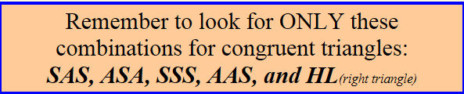
- Know your definitions and use them to determine missing facts

Statement | Reason
Given: $∡B≅ ∡Y, ∡A≅ ∡Z, \overline{BC}≅\overline{YX}$
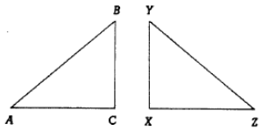
Prove: ∆ABC $≅$ ∆ZYX

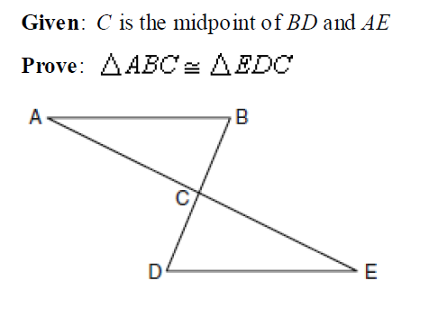

Statement | Reason

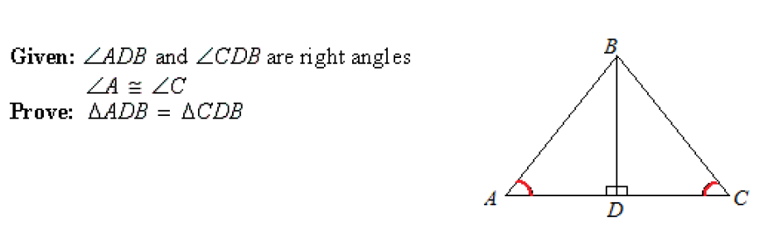

Statement | Reason

Statement | Reason

Statement | Reason

Statement | Reason

