Geometry CC – Mr. Valentino Name: ___________________________________ Unit 4 Lesson 1: Symmetry Date: _______________________ Period: ______
AIM: Identify and differentiate the three different types of symmetry: line, point, and rotational.
Do Now: You will be given a shape with a pattern on it. Find a classmate that is your match.
It’s time to discuss an important part of geometry…symmetry!
A line of symmetry is a line that divides a figure into ________ mirror images. The figure is mapped onto ________________ by a reflection in this line.
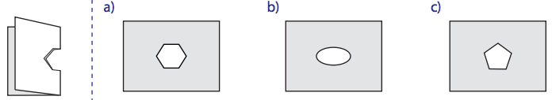
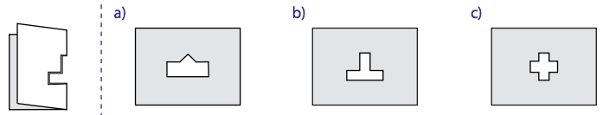
Let’s discuss some lines of symmetry on geometric figures:
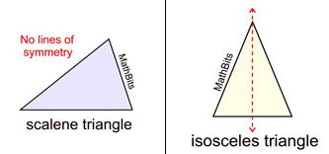

A figure has point symmetry when it looks the same when it looks the same __________________ as it does right-side-up (180 degree rotation).
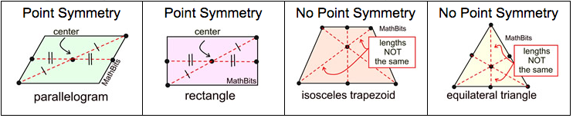
A figure has rotational symmetry if when rotating (turning or spinning) the figure around a center point by less than 360º, the figure appears ______________________.

The number of positions in which the rotated object appears unchanged is called the order of the symmetry.

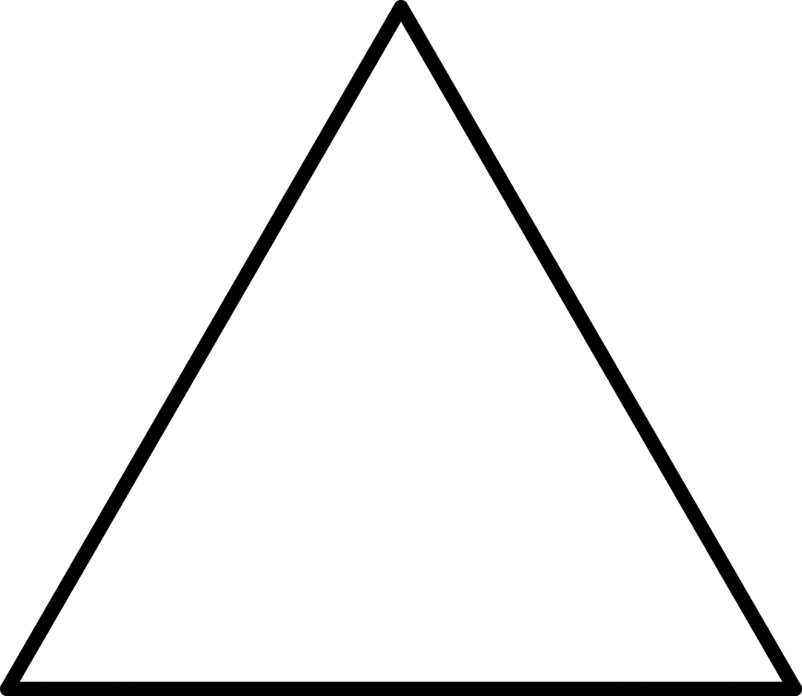
Let’s examine the point and rotational symmetry of some geometric figures:

Name __________________________________ Date __________________ Per _____
Does this figure have line, point, and/or rotational symmetry?
Figure # | Line Symmetry? | Point Symmetry? | Rotational Symmetry? | Of Order?

