Name: __________________________________________ Date: ________________________
Regents Review Problem Set 1
1. The cost of creating a commercial for television is modeled by the function $N\left(x\right)=110x+900$, where $x$ is the number of times the commercial is aired. Based on this model, which statement is true?
(1) The commercial costs $0 to produce and $110 per airing up to $900.
(2) The commercial costs $110 to produce and $900 each time it is aired.
(3) The commercial costs $900 to produce and $110 each time it is aired.
(4) The commercial costs $1010 to produce and can air an unlimited number of times.
Work/Explanation:

2. The graph below represents a jogger’s speed during his 20-minute jog around his neighborhood.
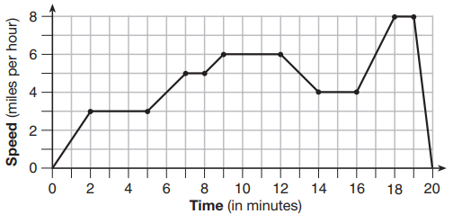
Which statement best describes what the jogger was doing during the 14-16 minute interval?
(1) He was jogging at a constant rate.
(2) He was decreasing his speed.
(3) He was increasing his speed.
(4) He was standing still.
Work/Explanation:

3. Four expressions are shown below. Work:
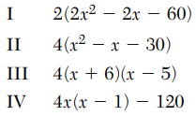
The expression ${4x}^{2}-4x-120$ is equivalent to
(1) I and II, only
(2) II and IV, only
(3) II, III, and IV
(4) I, II, and IV

4. Last week, a toy store received $355.60 for selling 20 stuffed animals. Small stuffed animals sell for $10.98 and large stuffed animals sell for $27.98. How many large stuffed animals did the store sell?
(1) 12 Work:
(2) 10
(3) 8
(4) 6

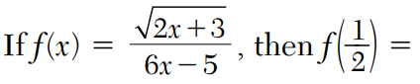
5.

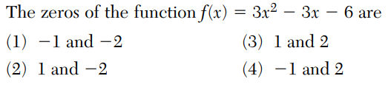
6. Sketch of the graph:

7. What is the domain of the following relation?
{(4,2), (1,1), (0,0), (1,-1), (4,-2)}
(1) {0, 1, 4}
(2) {-2, -1, 0, 1, 2}
(3) {-2, -1, 0, 1, 2, 4}
(4) {-2, -1, 0, 0, 1, 1, 1, 2, 4, 4}
Explanation of answer choice:

8. The following set of numbers is given:
$a=\sqrt{20}$ $b=2.5$ $c=\sqrt{225}$
Explain below why a + b is irrational, but b + c is rational.

9. Write the expression $5x+4x^{2}\left(2x+7\right)-6x^{2}-9x$ as a polynomial in standard form.

10. Solve the following system of inequalities graphically below and label the solution S.
$$3x+4y>20$$
$$x<3y-18$$

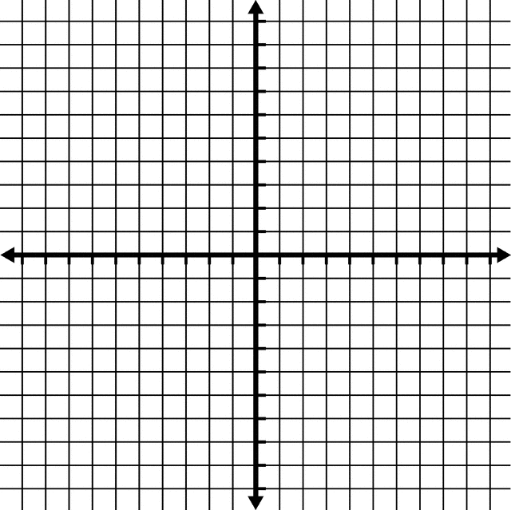

Is the point (3,7) in the solution set? Explain your answer below:
____________________________________________________________________________________________________________
____________________________________________________________________________________________________________
____________________________________________________________________________________________________________

